Unofficial Translation

GUIDANCE TO THE FORMULATION OF

WRITTEN PROCEDURE AND POLICY

BI-RTGS SYSTEM PARTICIPANTS

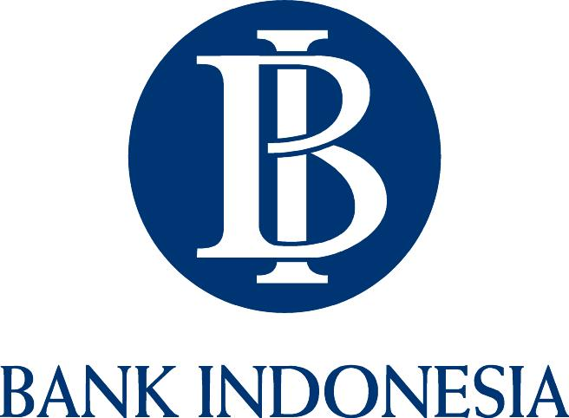

ACCOUNTING AND PAYMENT SYSTEM DIRECTORATE
BANK INDONESIA

